**Project Proposal**

**Continuing Hotel Sales CRM system**

**For National Select Service Hotel Chain**

**Consultants:**

Akshay Gupta, Joshua Meyer

**Consulting Firm:**

Apoco Designs

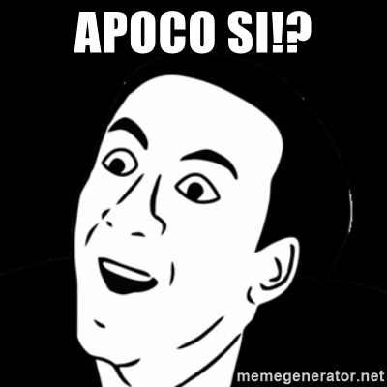

**4/21/2018**

**Table of Contents**

1. Executive Summary
2. Problem Analysis
   1. Client Information
   2. Vocabulary
   3. Consultant introduction
   4. Current Situation
   5. New CRM Implementation Problems
   6. Problem Analysis
   7. System Description
   8. Technical and Operational Feasibility
   9. Project Cost
3. Requirement Specs
   1. Core User Stories
   2. System Objectives
   3. Project Metrics
   4. Acceptance Criteria
   5. Behavioral Modeling
4. Design Specs
   1. Dynamic process Modeling
   2. Entity Relationship Diagram
   3. Object Modeling
   4. Alternative Design Possibilities
      1. Database Model 1
      2. Database Model 2
      3. Database Model 3
5. User Interface Design
   1. Database Design
6. Test Cases, Test Data, Test Results
7. User manual and Screenshots
8. Methodologies Used
   1. Construction methodology
   2. Documentation Methodology
   3. Alternative Methodology
9. Reflections
   1. Technical Skills
   2. Soft Skills

References

Appendix

**1.0 Executive Summary**

Apoco Designs is working with La Quinta Inn and Suites, Stillwater, OK on a project to develop a functional prototype for a hotel sales CRM system. The reason for this project is the current CRM system is a combination of paper and electronic documents along with a poorly implemented freeware Zoho CRM system. The Zoho system lacks any hotel specific functionality and is only somewhat helpful for some sales pipelines. The lack of a formal sales system and sales information system has hindered the La Quinta’s ability to attract large corporate clientele and also make it difficult to provide excellent customer service to clients that book through sales. Apoco Designs was commissioned to build a functional prototype to show management of the La Quinta Stillwater that a custom hotel specific CRM system will improve the sales process, increase group and corporate customer satisfaction and decrease errors caused by the current sales process.

Apoco Designs has analyzed the problems with the current CRM system and provided La Quinta Inn with a custom hotel sales pipeline specific CRM system. We have developed the new CRM application to act as both a contact manager and deal manager for the sales process. This new CRM system will help make hotel’s sales more efficient by eliminating issues such as data redundancy, long email threads, switching between multiple applications to track the information about a prospective contact or a corporate deal and misplacing paperwork. We have used MS Access as our tool to develop the user interface and database for the new functional prototype hotel sales CRM system

Initially, the scope for the project was broader and included having a plan to make the proposed prototype CRM application integrated with La Quinta’ corporate CRM system which is Salesforce, Central Reservation System (CRS) and Global Distribution System (GDS). But, with the recent buyout of La Quinta Hotels by the Wyndham Hotels group, we decided to limit the scope of our application to the individual unit only .i.e. La Quinta Inn and Suites, Stillwater, OK.

**2.0 Problem Analysis**

**2.a Client Information**

**Client Organization:** La Quinta Inn and Suites Stillwater

**Main Contact:** Dean Schrock

**Contact Position:** General Manager La Quinta Stillwater

**Address:** 5285 W 6th Ave, Stillwater, OK 74074

**Phone:** 405-564-0599

**2.b Vocabulary**

**LNR:** local negotiated rate. These are rates that are negotiated between an organization or company and the hotel. Basically the organization get a discount on hotel rooms because they bring X number of rooms per year to the hotel.

**Group Rate:** These are discounted rates when an organization need a large number of rooms over certain dates. Wedding blocks are typical example along with church retreats etc.

**PMS:** property management system. This is the on property information system for the hotel which is in charge of room management, reservations, accounting, and billing.

**CRS:** Central Reservation System. This is a system that a hotel brand uses that takes reservations from the hotel’s website, call centers and usually interfaces with other CRS and GDS systems then transfers that information to an individual hotel’s PMS system. The CRS is a middleman between GDS or customers and the PMS system.

**GDS:** global distribution system. This is another middle man that is hotel and hotel brand agnostic and many travel agents 3rd party bookings are made through a global distribution system which interfaces with a brand CRS system which then transfers the information to the hotel’s PMS system.

**MRR:** Meeting Room Rental, which is the rental of meeting space at a hotel.

**Lead:** A contact or company that may want to do business with the hotel or may be developed into doing business with the hotel.

**Deal:** Buying process when a client decides to buy some service or item from the hotel.

**2.c Consultant Introductions**

Apoco Designs is a new software consulting firm that provides software design and hospitality consulting services to a variety of businesses in accommodation, restaurant and gaming industries. We specialize in consulting with clients on process redesign, customer satisfaction and hospitality specific software. The team is headed by Joshua Meyer who has 10 years of experience in the hospitality industry. He just started his master’s degree in MIS and is excited to be improving hospitality information systems and processes. Josh is going to be acting as Project Owner and Scrum Master for the project because Josh is intimately familiar with the select service hotel chain’s sales processes and current information systems. Akshay Gupta has years of experience in the financial world and recently decided to add software development to his list of skills and is now pursuing a master’s degree in MIS. Akshay brings years of development experience to the consulting team and will be the teams lead developer.

A ROO

**3.d Current Situation**

The Hotel CRM development project is a continuing project to design and execute a functional prototype of the core functionality for a new company wide sales CRM system for individual La Quinta Inn and Suites properties. This system is being developed because Joshua Meyer was the Director of Sales at a local La Quinta and found that the brand had no formal on property sales process or information system for maintaining relationships with LNR, group block and meeting room rental clients at the individual property level. Most La Quinta hotels are operated without a dedicated hotel staff, which means that the hotel GM or front desk manager is responsible for hotel sales in addition to their hotel operations duties. That means any time taken to perform sales functions takes away from the managers ability to perform other important operational tasks. Having a CRM system that reduces the amount of time for data entry and retrieval would benefit the company.

The sales process that is being implemented by the new CRM system was first developed by Josh during his first few months working as Director of Sales at the La Quinta. Once that process was developed, Josh started looking for ways to automate and streamline the sales process to reduce the amount of redundant data required for the developed sales system that was comprised primarily of paper and electronic documents. He signed up for a free version of Zoho CRM system but found that the system would not allow customization the software without a hefty per month cost to the hotel. Josh then started designing a custom CRM system using various relational database systems including Microsoft Access, SharePoint and MySQL. In the fall of 2017, he led a group of students to build, document and design a database in MySQL that satisfied the core requirements for a custom La Quinta Specific sales CRM system.

The three primary uses for the new sales CRM system on a property level would be contact, lead and deal: creation, management and tracking. By having a standard CRM and sales process across the brand would standardize individual properties sales efforts, and increase the amount of time general managers can spend actually selling vs pushing paper.

**System Benefits**

● Reduced data redundancy

● All employees can be involved in the sales process

● Better communication between sales, front desk and housekeeping pertaining to customer needs.

● Increased sales consistency across the brand

**System Constraints**

● System Cost

● System Training

● System complexity

● Integration with other hotel systems

**2.e New CRM System implementation problems**

The initial plan for the new CRM System was to use the already designed MySQL database and design the user interface and business logic using Microsoft PowerApps. Unfortunately, PowerApps requires a business or school Microsoft 365 membership and Oklahoma State University has revoked student’s access to PowerApps and the La Quinta Stillwater is unable to provide access to their corporate 365 subscription. This forced the team, to instead choose to use Microsoft Access for the prototyping work due to the database also being created in the Access and the simplicity of GUI design using Access forms, macros and VBA. The plan is to build a prototype hotel Sales CRM using Microsoft Access.

**2.f Problem Analysis**

● Lack of standard sales process across the La Quinta brand

● Stillwater location uses combination of paper document, electronic document and CRM systems for tracking customers through the sales process.

● Communication of sales information is difficult

● Current sales process has multiple instances of redundant data entry

● Company sheet data has 1-3 week lag before the information is updated in La Quinta CRS and various GDS and web databases due to manual electronic document processing.

● La Quinta wants every employee to be a salesperson and currently does not provide a great mechanism to communicate and evaluate sales information among pertinent hotel employees

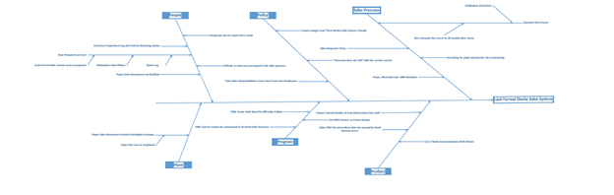

**2.g System Description**

There are three possible solutions for the sales problems faced by the La Quinta Stillwater. One is editing a prebuilt sales CRM solution like Salesforce or Zoho CRM, which would reduce development time and development cost. However, the long term cost of Salesforce and Zoho make them prohibitively expensive because in order to edit the software you must pay around $25-$35 dollars per user, which makes is expensive for the benefits gained from the system when it need all hotel employees to access the CRM system. Below is solution matrix, which shows a list of Items that were used to rate each possible solution and are weighted by their importance. The highest weight has gone to cost, ease of development and whether the company is already using the software. The reason that these are weighted the highest is because if La Quinta is already paying for PowerApps and Microsoft Access they incur less cost for each user of the system. Ease of development was chosen because the project is developing a functional prototype and it is not worth the developer’s time using a difficult to use development platform. While PowerApps was the overall winner in the solution matrix the developers are unable to use PowerApps due to Apoco’s lack of a corporate or education office 365 subscription that includes PowerApps.

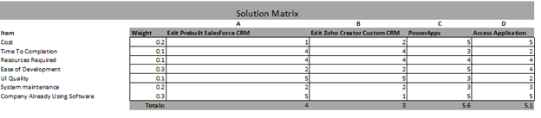

**2.h Technical and Operational Feasibility**

**-Technical Feasibility**

The project is technically feasible because the developers use of Microsoft access for the prototype application. Both developers know how to develop Microsoft access applications and Microsoft already has CRM templates for access which shows that access is able to create CRM systems. Additionally the underlying databases have already been built and tested and so the underlying database already has been proven to work and may only need minimal changes.

**-Operational Feasibility**

The application as designed meets the core user requirements outlined in the user stories 1-9 18, 16 and 18. As long as the new system follows it design the system should be operationally feasible for the core components of the new prototype CRM system.

**2.i Project Cost**

The main costs for the function prototype Hotel Sales CRM system are the costs of the Apoco consultants and the development software. Implementation costs are minimal because all corporate La Quinta computers already have Microsoft access installed and also have Microsoft 365 accounts. Midway through the project the systems owner cancelled the project due to a merger with Wyndam and their decision to merge their information systems with those of Wyndham. This removed the costs for a windows server and Microsoft SharePoint as the software developed in access would no longer need to be ported to SharePoint server.

Below we see that Labor Costs are $4325 and the Material cost for software is $2217 bringing the total for the project to $6542.

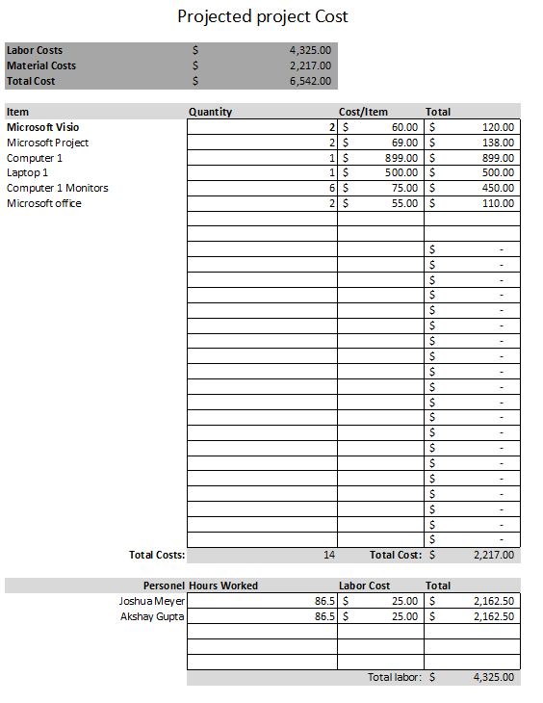

**Project Gantt Chart**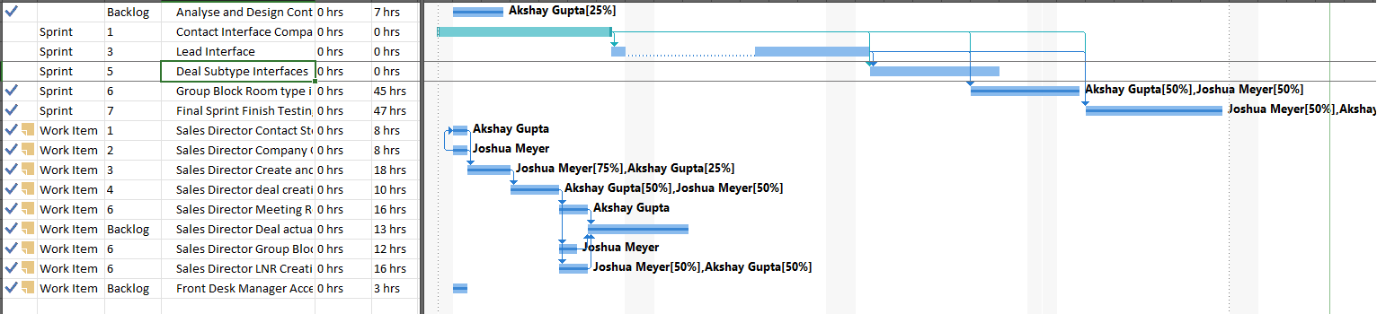

**3.0 Requirements specs**

**3.a Core User Stories**

1. As a **Sales Director** I want to store contact information so that I can keep track of my contacts and their companies. I need contact names, phone numbers, email, physical address, birthdays, anniversaries and place for notes.
2. As **Sales Director** I want to store company information so that I can keep track of my corporate clients and the company contact(s). I need their main phone number, fax number, email, website, mailing and billing address. I also need to know what contacts I have that are associated with this company.
3. As **Sales director** I need to be able to create leads from my companies so I can track an entities progress through the hotel’s sales cycle.
4. As **Sales director** I need to be able to turn my leads into deals once the lead has been qualified. This is so I can keep track of specific customer needs for each deal made and store all information needed to be entered into various hotel systems.
5. As **Sales Director** I need 3 different deal types. This is because customers that have different deals have different needs and those needs have to be entered into different systems. Deal Types are LNR, Group Block and Meeting Room Rental.
6. As **Sales Director** I need to be able to be able to create and manage Meeting Room Rental information so I can set room and offer services that meet client’s needs.
7. As **sales Director** I need my Group Block deals to be able to track forecasted vs actual room pickup.
8. As **Sales Director** I need to be able to granularly create group blocks with a variety of different room types, lengths of stays and pricing to fulfill the needs of various clients and be able to track my sales performance overtime and also forecast revenue and availability.
9. As **Sales Director** I need to be able to quickly set up LNR rates with corporate clients so I can get the rates approved by revenue management and have the rate information added to various PMS, CRS and online systems.
10. As **Front Desk Clerk** I need to be able to create new sales leads so that they can be evaluated by the GM and Sales Director and meet La Quinta’s Everyone Sells goals.
11. As **Front Desk Clerk** I need to be able to view deal data so I can update pertinent systems and fix mistakes in reservation and rental setups in addition to confirming customer needs without needing to consult sales.
12. As **Housekeeping** I need to be able to create new sales leads so that they can be evaluated by the GM and Sales Director and meet La Quinta’s Everyone Sells goals.
13. As **Executive or Assistant Executive Housekeeper** I need to be able to see group stay information so I can schedule housekeepers and meet individual clients housekeeping needs without having to consult with sales staff.
14. As **Maintenance Staff** I need to be able to create new sales leads so that they can be evaluated by the GM and Sales Director and meet La Quinta’s Everyone Sells goals.
15. As **General Manager** I need to see reports on the sales funnel and how much money is in the various stages of leads and deals so that I can see how sales is performing and forecast revenue.
16. As **General Manager** I also need all functions that sales has because as General Manager I am the ultimate on premises authority on sales.
17. As **General manager** I want to have a report that includes all sales calls made on a weekly basis, all new leads that were generated in the week and all new deals that were created in the week and all deals that closed in the week so I can track sales progress and keep track of what sales is doing ensure the sales manager are making the hotel money and are a good investment.
18. As **Front Desk Manager** I also need all functions that sales because I am help with sales and am in charge of interacting with clients. I need to be able to update and correct sales information along with create new contacts, companies, leads and deals while sales is not on property.

**3.b System Objectives**

* Remove the redundant data entry from the sales process.
* Remove the need for paper and electronic file sales system
* Improve data consistency by enforcing data type and Requirement rules
* Reduce the amount of training required to use the sales system
* Reduce the amount of data entry Required by Sales Director and or General Manager
* Allow Front Desk, Executive and Assistant Executive Housekeeper to view Group block and LNR data
* Improve corporate and LNRs sales by reducing quote times, and standardizing the sales process throughout the brand.

**3.c Project Metrics (Key Performance Indicators)**

1. **Cost of the project** – The cost of the proposed solution which is approx. $6500 will be absorbed within the first year of implementation as it will boost the revenue of the hotel by approx. $17,200 and help in achieving better customer satisfaction.

2. **Ease of Development** – Developing the new system will be easy because access is already used by the company and the consultants already have experience developing and implementing access information systems.

3. **Time for development** – It will take approx. 2 months to develop the prototype system. During that period, the old system will be working as usual.

4. **Resource utilization** – It is the measure of how team members are spending their time while working on a project. It is the comparison of billable vs. non-billable activities.Over the life cycle of the software development, the staff involved in the development are assigned with the tasks keeping in mind the efficient utilization of the time for development, skills of the team involved, keeping the cost low and respecting the time of the system owner nad hotel employees during client meetings.

5. **User Requirements** – Our client wants a system that will improve user efficiency and increase revenues. The prospective prototype CRM system needs to meet at least 90% of the core requirements listed in operational feasibility.

**3.d Acceptance Criteria**

The Prototype will be accepted if it fulfills all of the user stories 1-9 18, 16 and 18. User stories 17 and 15 do not need to be fulfilled and are beyond the scope of the prototype and core functionality of the Sales CRM system.

**3.e Behavioral Modeling (Use Case Diagrams)**

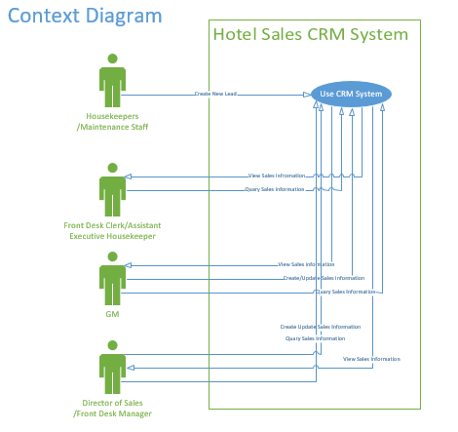



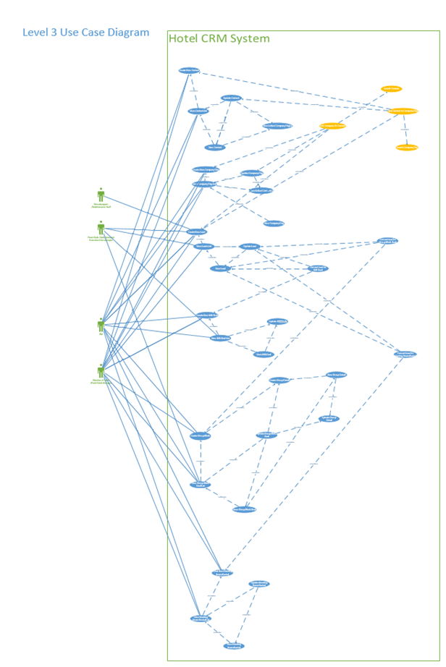

**Level 3 Use Case Diagram Subsystems**

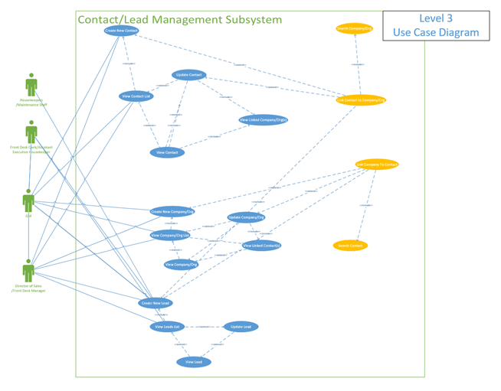

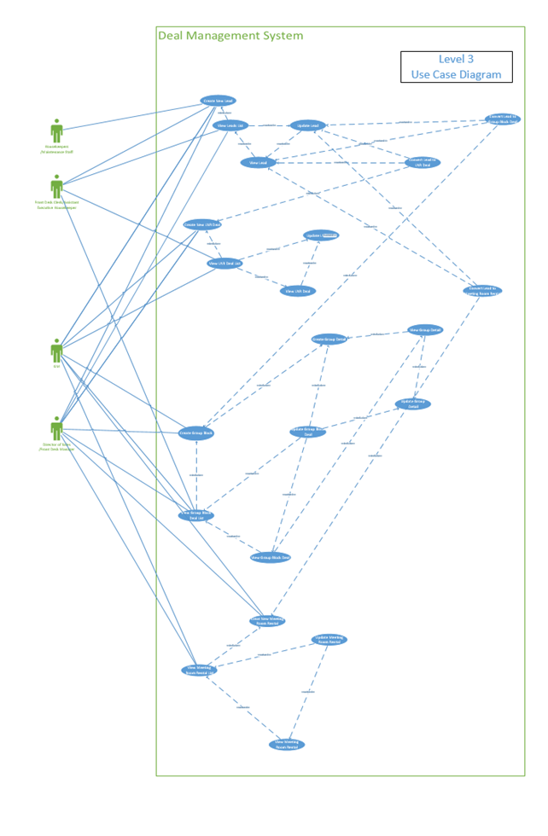

**4.0 Design Specs**

**4.a Dynamic Process Modeling (Data Flow Diagrams)**

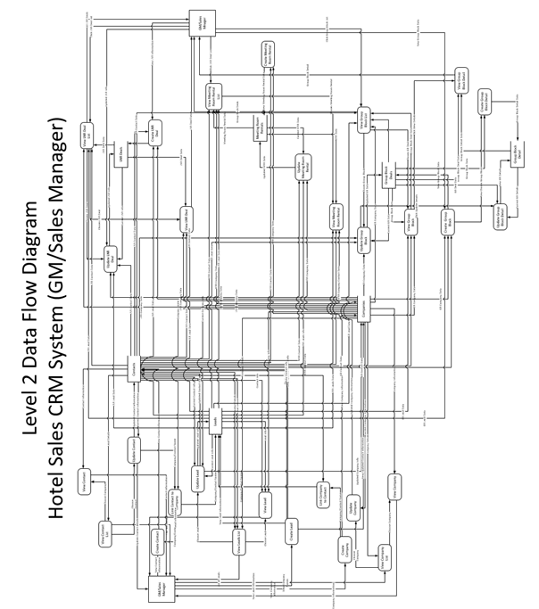

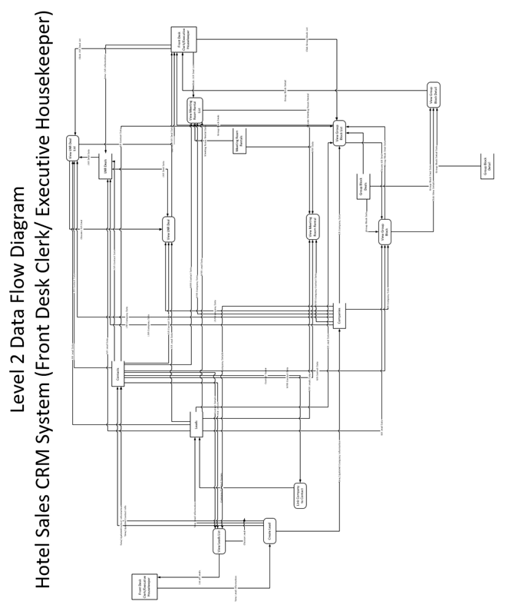

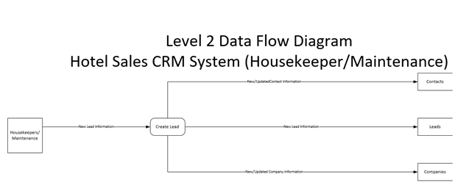

**4.b Entity Relationship Diagram**

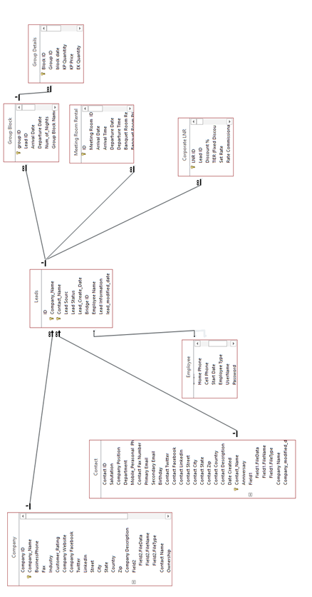

**4.c Object Modeling (UML Class Diagram)**

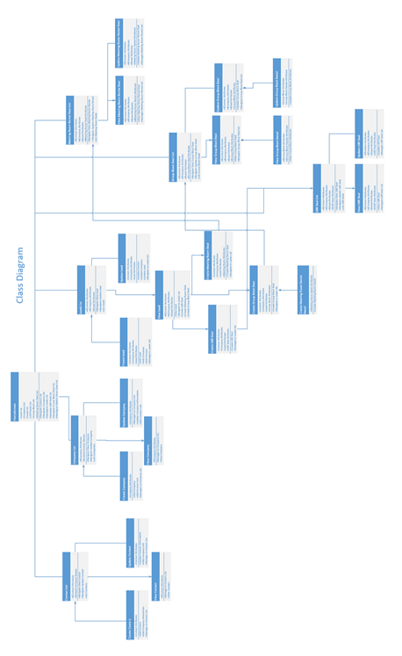

**4.d Alternative Design Possibilities**

Since the application is being implemented using Microsoft Access the primary alternative design work involves the backend database design. The Forms which operate on the backend will look and behave similarly regardless of the backend database.

**-General System logical and Physical Design**

4.d.i Database Model 1

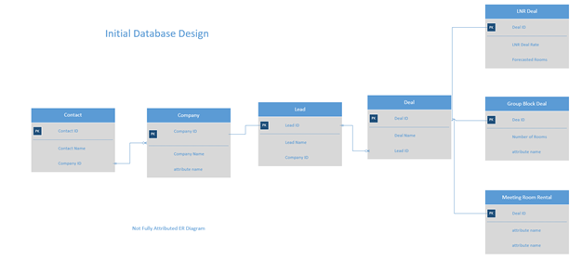

The problem with the model 1 design is that it does not allow reciprocal relationships between company and contact. Because the database functions as a contact manager some companies do not have a contact and some contacts do not have a company. The initial design did not allow a contact without a company. Similarly did not allow a lead to have a contact without a company. This is not consistent with real world scenarios at the hotel were individual customers (contacts) which are not involved with any company can eventually become a lead and a deal. Additionally, while not shown in the Basic ER diagram above the Group block Table needed an additional table to hold room types and quantities in a one to many relationship because a Group Block deal could involve different room quantities, room types, room prices from day to day during a groups stay at the hotel.

4.d.ii Database Model 2

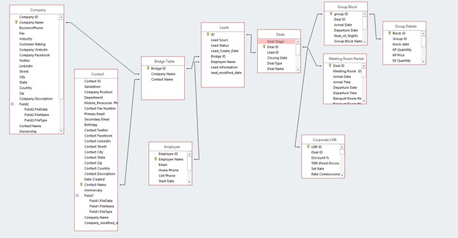

The problems with the second database design mostly have to due with parsimony and ease of implementation in Access. What the design team found was that the 1:1 relationship between Bridge table and leads and leads and deals made the Bridge table and leads table redundant. Once the team started creating forms they found that the redundancy in the design also created problems implementing sub tables easily in Microsoft Access due to Access having difficulty navigating table relationships through multiple tables. The team found no problem removing the bridge table and turning the lead table into a bridge table for the contact and company table. The only problem it created was that now you have some leads that are only created to link company and contacts and may not actually be a new lead. This is easily solved just using a filter and adding a blank category to lead status and filtering the blank lead status from leads forms.

The second problem was another bridge/parent table called deals. The deals table basically only had 4 attributes that were shared among the deal sub-tables, LNR, Group Block and Meeting Room Rental Deals. The consulting team found implementation application logic was easier by removing the deals parent table and adding the 4 attributes that were in the deals table to each sub-table. Now Leads table is the parent table that directly connects to the 3 deal sub-tables. Removing the deals table causes redundancy in the database because the attributes in the deals table have to be repeated in each separate deal type (Group Block LNR and Corporate). This redundancy is acceptable for the advantages and parsimony that is gained from the removal of the table. It will cause the database to only be in 2NF instead of 3NF.

4.d.iii Database Model 3

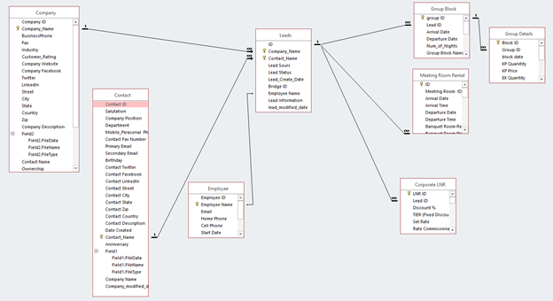

This is the chosen design because it is the most parsimonious design that meets the user requirements. While employee is included in the ER diagram that table will not be implemented in the prototype application.

**5.0 User Interface Designs**

The User Interface Designers are wireframes created in Excel which roughly model what the final prototype user design will be.

**Navigation Bar**

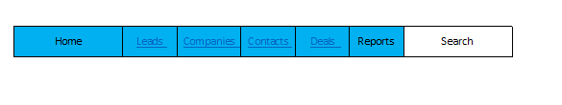

This is the main navigation bar to navigate to the main sub areas of the application. This bar will be displayed above every form shown below.

**View/Update Contact**

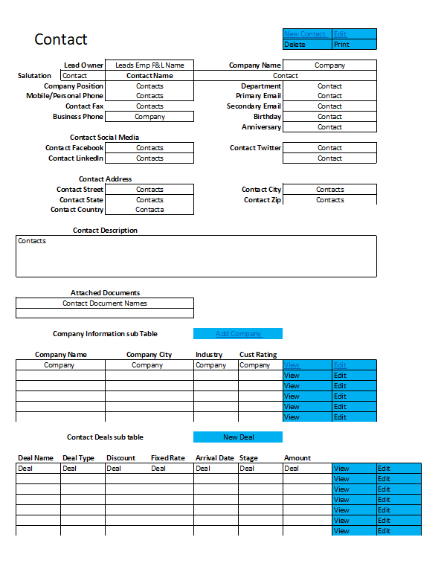

Contact view which includes Company and Deals Sub-tables.

**Contact List**

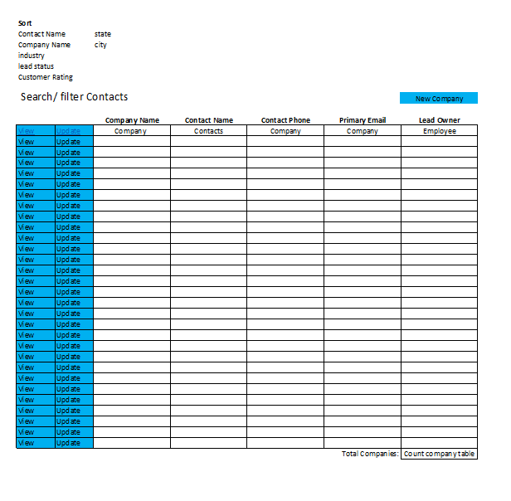

This is the main table that is navigated to from the main navigation bar. From this form view create and update individual contact information. It also lists all of the contacts currently in the database.

**View/Update Company**

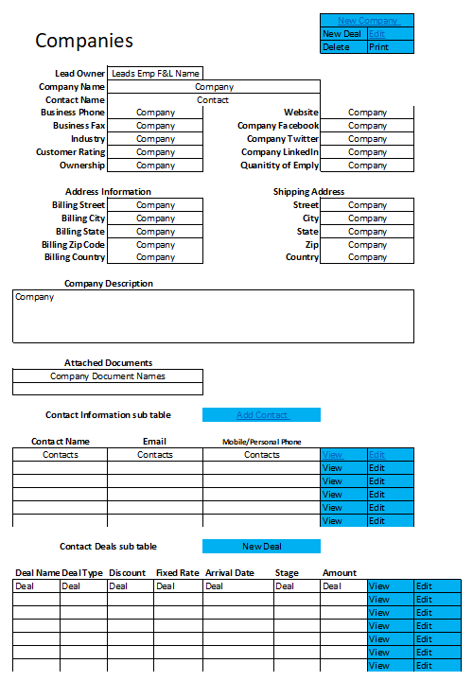

Functions similarly to View/Update contacts form except the main data is from company table and contact and deals subforms

**Company List**

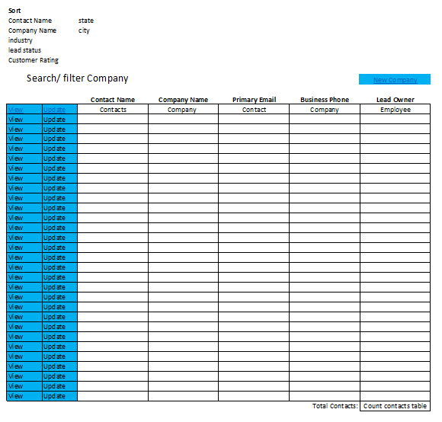

Functions the same as Contact list except with main data being company data.

**View/Update Lead**

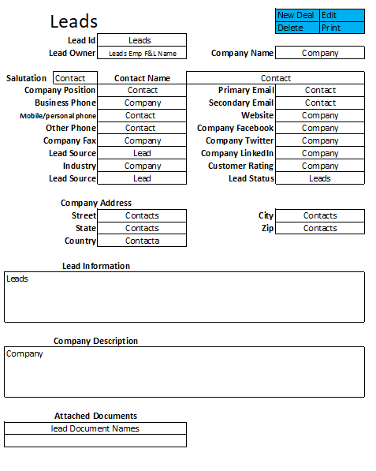

View/update lead combines updating leads contact and company databases.

**Leads List**

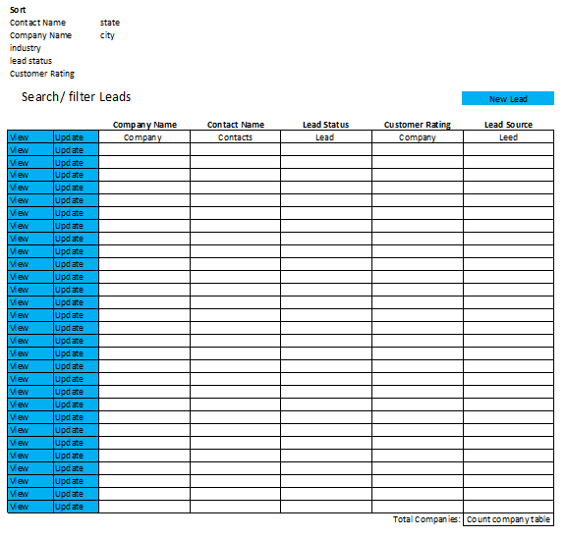

Functions similarly to contact list, however it shows lead, contact and company name data.

**LNR, Group Block ad Meeting Room Rental Deals**

LNR Deal, Group Block Deal and Meeting Room Rental Deal will have similar UI Designs for their View/Update forms and List forms except they will have attributes that correspond to their respective deals.

**5.a Database Design**



See alternative design for database design considerations.

**6.0 Test Cases, Test Data and Test Results**

See Appendix A.3

**7.0 User Manual and Screenshots**

See Appendix A.2

**8.0 Methodologies Used**

**8.a Construction Methodology**

The construction methodology used was an agile, semi-scrum methodology. The methodology was chosen for a variety of reasons. The first, is the small number of group members in the consulting team made communication simple and stringent adherence to a methodology for team and project cohesion was not needed (thus semi-scrum over pure scrum methodology). The group used face to face meetings to communicate overall design and left the details up to the individual members and for texting and emails. The second reason the semi-scrum methodology was chosen for construction was that the project was a continuation of previous team’s work that had already completed most of the overarching analysis and design. The Apoco Design team’s job was to fill in the analysis and design details and most importantly build a functioning prototype application. Since the team was already given a working database they simply had to tweak the design to meet the new user requirements and design requirements they found during their analysis and design phases. Lastly, the group leader was the lead of the previous team that built the initial database and already had an incredible amount of domain experience both in both the business and software sides of the hotel sales CRM application. This made the daily scrum meetings irrelevant as most important details could be easily communicated to the one group member that did not possess the domain knowledge in sprint planning meetings. If that team member had questions throughout the sprint they could simply text or meet with the other team member as necessary. Another change made to scrum methodology is that due to the intense documentation requirements required (For College Credit) sprints were scheduled much longer than necessary in a real life scrum environment to account for time wasted on documentation and to account for scheduling difficulties with graduate student consultants.

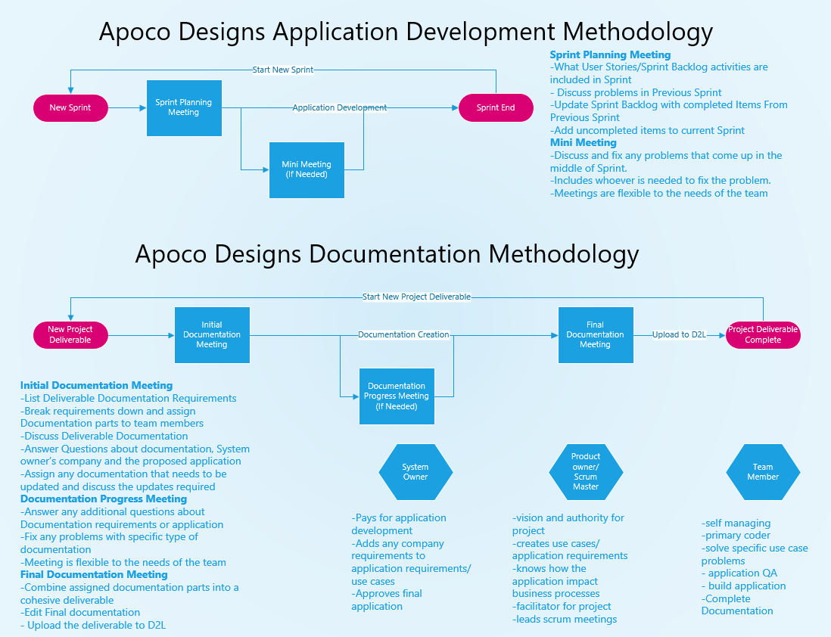

**8.b Documentation Methodology**

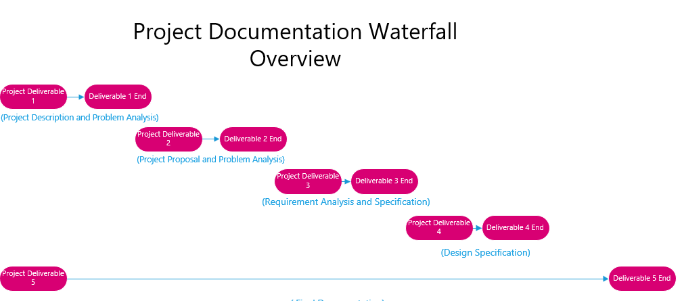  
The documentation methodology was dictated by the project deliverable schedule set by Dr. Dalal. The documentation methodology was a waterfall development methodology. That started with project description, progressed to problem analysis and ended with design specification. All of the previously mentioned Deliverables had to be implemented in sequence and it generally was not possible to progress to the next deliverable without completing the previous deliverable. Final deliverable 5 is a combination of all of the previous deliverable materials and only could be completed after deliverables 1-4 were finished.

One other important documentation method used by Apoco Designs was “just good enough documentation”. This was done because the team already understood the general requirements for the semi-functional prototype they would be building. The core requirements for the application did not change throughout development of the prototype application. One aspect of “just good enough” documentation prioritizes semantically correct documentation and not syntactically correct documentation. This is because the system owner does not have a background in UML and there is no reason to waste time creating perfectly syntactically correct documentation that will only be used by system owner and non-technical users who do not understand the syntax anyways. Thus the diagramming was done to simplify the documentation and make it easier to understand by non- technical users. This is exemplified by the Use case diagram that basically mimics the data flow diagram and class diagram and was the only diagram required to complete the prototype application due to the simplicity of the applications design. While creating non-syntactically correct diagrams is generally bad practice in system analysis and design it fits with the team’s documentation methodology that prioritizes speedy creation of documentation over quality of documentation. The speedy creation of documentation allows team members to spend more time building a working prototype rather than wasting time creating documentation that will be thrown out when the actual system is developed (or in the case of this specific instance were the project was cancelled).

**8.c Alternate real world methodology**

The most difficult part of the project was figuring out how to rectify the waterfall documentation methodology with the scrum application development methodology. This forced the team to basically simplify both methodologies. The simplification of the waterfall documentation was to use “just good enough documentation”. The simplification of the scrum methodology involved scrapping all of the required scrum events, except for the initial sprint planning meetings and left other meetings up to the needs of the team. The team also felt that trying to meld waterfall documentation with scrum code development in a real world organization would result in poor quality software and great documentation that is out of date as soon as it is complete. This is because waterfall work on the documentation holds the scrum software development team back from completing code in a timely manner. The team believes that a software development project needs to start with waterfall methodology for the initial problem analysis and overall software design.Then once the programming team starts coding. The coding and analysis and design teams needs to transition to a scrum methodology and only produce only enough documentation to get by and prioritize working code. This increases the likelihood that the project gets done on time and meets the user requirements. If the system owner needs quality highly detailed UML documentation. I would set up a second team that trails the product development team by a sprint or two that only creates the UML documentation for the client. This would allow the client to receive quality documentation and allow the project development team to get done in a reasonable amount of time.

**9.0 Reflections**

**9.a Technical Skills**

Working on the Hotel CRM project developed the Apoco Design team’s problem solving, analytical and software design skills. Neither of the consultants have a background in computer science. Working on a real world project gave both of them the experience of how messy actual analysis and design work becomes when working on actual projects.

The biggest addition in term of technical skills for the team was the opportunity to have a hands on experience with the system development lifecycle (SDLC) that includes planning, requirement analysis, defining requirements, designing the product architecture, developing the product, testing the product and finally, deploying the product once it satisfies client requirements. In the design analysis phase, the team learned how to draft data flow diagrams which were broken down till level 2. Other technical skills which we acquired was working with Unified Modelling Language (UML). We used object modelling technique that uses UML to visualize and test physical objects before developing them. We also used the class diagram in the UML which is a type of static structure diagram that describes the structure of a system by showing the system's classes, their attributes, operations (or methods), and the relationships among objects. We also enhanced database design and construction skills and working with MS Access as a platform for building the database as well as the front end interface. In terms of methodology, it was good experience using both agile and waterfall methodologies during the project.

**9.b Soft Skills**

This project enhanced the team’s ability to work in a team environment and interacting with clients. Understanding how to communicate with clients during interviews, and meetings to generate user requirements was one of the best soft skills gained from the project. Learning how to effectively communicate written analysis and design specifications was also helpful.

As a business or software analyst, it is really important to have core skills such as good communication skills, problem-solving skills and critical thinking skills. Our team got to improve all of them over the course of the Hotel Sales CRM Project.

**References**

The initial analysis and database used in this project were from a previous project that one the Apoco’s consultants worked on in a previous semester.

Meyer, J. (2017). Trial Sales Database 11. Stillwater, Oklahoma. Retrieved January 1, 2018. This is the Initial Access database that was modified for the project

Parra, J., Joshi, S., Joshua, M., Loya, S., & Chamkavi, M. J. (2017). Customer Relationship Management Database with Existing Zoho and Paper Based CRM System (pp. 1-20, Rep.). Stillwater, Oklahoma.

**Appendix**

A.1 Communication with Client

A.2 User Manual

A.3 Test Cases, Test Data and Test Results

**A.1**

**Communication with Client**

Most of the email pertaining to the project were lost or unavailable due to the project manager leaving the company back in January and not having access to their corporate email account. Most of the other emails were deleted due to the project manager deleting any proprietary emails from their personal email due to leaving the company and not wishing to keep proprietary information. If you need proof of project communication with the system owner you can talk with the General Manager of the La Quinta Stillwater.

Email Outlining the End of the Project due to Sabre adoption

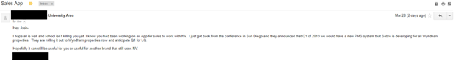

**User Manual Josh**

**A.1**

**Hotel Sales CRM User Manual**



Apoco Designs



**Table of Contents**

This manual assumes that you have at least basic knowledge of hotel sales and hotel operations. This manual was created for Directors of sales and General Managers to familiarize themselves with the basic functions the Hotel Sales Customer Relationship Management (CRM) Software.

1. Sales Terminology

2. Basic Navigation

3. Software Sales Pipeline

4. Create new

a. Contact

b. Company

c. Lead

5. Contact

a. Contact List

b. View Contact

c. Edit Contact

6. Company

a. Company List

b. View Company

c. Edit Company

7. Leads

a. Leads list

b. View Lead

c. Edit Lead

8. Local Negotiated Rate (LNR) Deals

a. LNR Deal List

b. Create New LNR Deal

c. View LNR Deal

d. Edit LNR Deal

9. Group Block Deals

a. Group Block Deals List

b. Create New Group Block Deal

c. View Group Block

d. Edit Group Block

e. Add Group Block Details

10. Meeting Room Rental (MRR) Deals

a. MRR Deals List

b. Create New MRR Deal

c. View MRR Deal

d. Edit MRR Deal

**1.0 Sales Terminology**

LNR: local negotiated rate. These are rates that are negotiated between an organization or company and the hotel. Basically the organization get a discount on hotel rooms because they bring X number of rooms per year to the hotel.

Group Rate: These are discounted rates when an organization need a large number of rooms over certain dates. Wedding blocks are typical example along with church retreats etc.

PMS: property management system. This is the on property information system for the hotel which is in charge of room management, reservations, accounting, and billing.

CRS: Central Reservation System. This is a system that a hotel brand uses that takes reservations from the hotel’s website, call centers and usually interfaces with other CRS and GDS systems then transfers that information to an individual hotel’s PMS system. The CRS is a middleman between GDS or customers and the PMS system.

GDS: global distribution system. This is another middle man that is hotel and hotel brand agnostic and many travel agents 3rd party bookings are made through a global distribution system which interfaces with a brand CRS system which then transfers the information to the hotel’s PMS system.

MRR: Meeting Room Rental, which is the rental of meeting space at a hotel.

**2.0 Basic Navigation**



Primary Navigation of the software is done through the navigation buttons at the top of the screen. The light blue and orange buttons navigate to the contact management functions of the software and the dark green buttons navigate to the Hotel Sales Deal functions of the software. The dark blue button indicates which part of the software you are currently in. In the case of the screenshot above we are currently working the lead function of the software.

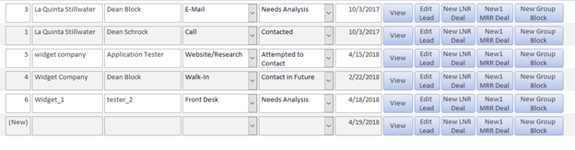

The software is made up of a series of lists which list all the customer and sales information contained within the software as seen above. Additional information can be shown about any piece of data in a list by clicking the view button which will navigate you to another screen with additional information about that item. If you need to change an item in a list simply click the Edit button and it will navigate you to a screen that will allow you to change data for that item.

In the Leads list you have additional buttons for leads that allow you to create a new LNR, MRR or Group Block deal from a lead. These buttons navigate you to a screen where you fill out additional information for that deal type.

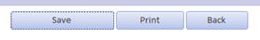 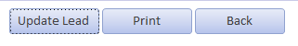

Navigation inside of the various New, view and Edit functions is comprised of 4 main buttons. These buttons are Save, Update, Print and Back. Save button saves whatever information was entered into a form. The Update button similarly saves any changes made in an Edit form. The Print button allows you to print the data in the current form. The Back button allows you navigate to the previous screen. **It is important to always Save/Update any new information or changes to a form before navigating away from the form. If you navigate away from the form without saving or updating the information will be lost!**

**3.0 Software Sales Pipeline**

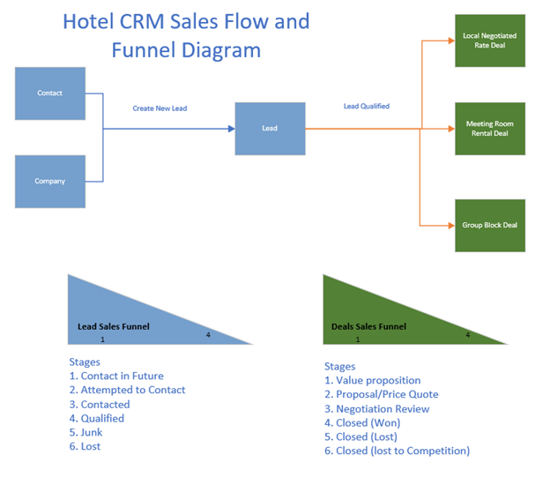

The Flow of information through the system starts with the creation of contact and company data. Once a contact or a company shows interest, or you know from research is a potential business opportunity the contact, company or combination of both become a lead and enter the leads sales pipeline. Leads sales funnel begins with Contact in Future and ends at either Qualified Junk or lost. As a lead moves from Contact in Future to Qualified it becomes more likely that the prospective customer will book business with the hotel. However, it at the same time more prospects drop out as they progress down the lead funnel and become either Junk or lost based on why they became disinterested in creating a deal with the hotel. Once a deal is qualified it should be converted to a deal and then enters the deal sales funnel. This starts at value proposition, which is were the hotel is talking to the client to gain enough information about the clients needs to create a quote. Once the hotel creates a quote and communicates that to the customer the deal stage becomes Proposal/Price Quote. The customer can either accept the quote unaltered which leads to Closed (Won) or they may request additional changes to the Quote, which is the Negotiation/Review Stage. Hopefully the potential client accepts the altered offer and it ends in Closed (Won) which means the hotel won the clients business. However, the client may not wish to due business with the hotel during any part of deal making process and they will drop out, Closed (Lost), or make a deal with a competing hotel, Closed (Lost to Competition). Just like the lead sales funnel as customer progresses through deal funnel customers drop out and the likelihood that a customer will book business with the hotel goes up.

**4.0 Create new**

**4.A Contact**



Create a new contact by first clicking on the new contact button.

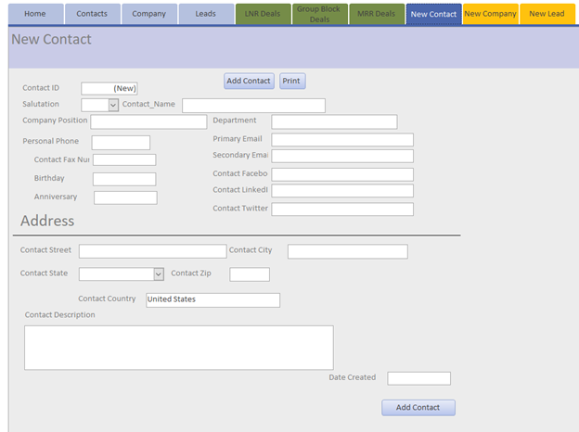

Then enter all of the new contact’s information. Make sure to create a contact name otherwise the software won’t allow you to save the new contact.

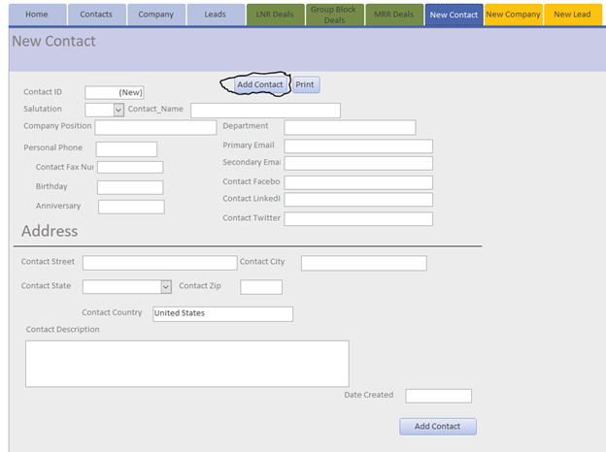

Click the Add Contact button and it will save the new contact. You can also print the new contact if you wish. Then you can navigate away from the create new form by clicking on any of the other top navigation buttons.

**4.B Company**



First Click the New Company Button.

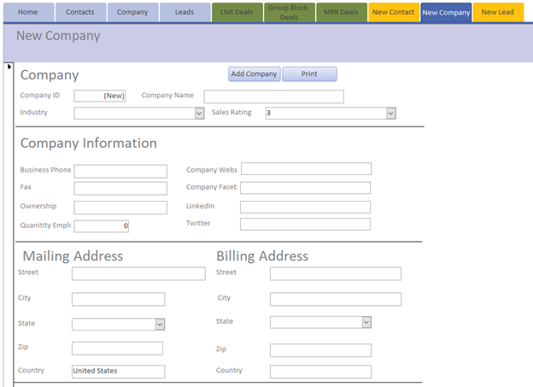

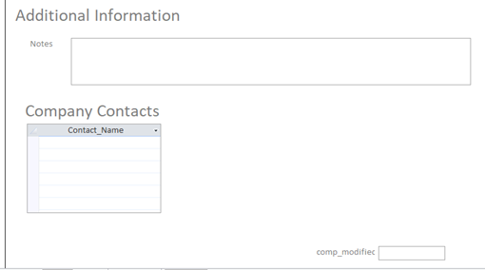

Then you can add all of the New Company Data. Make Sure you create a company name and if you find that you have multiple companies with the same name the company with the company city in the name.

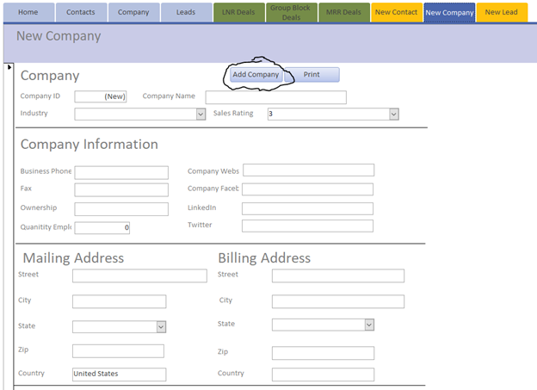

Once you are finished entering the company information click add company to save the company information. You can also print out the company information if you wish. You navigate away from the screen using the navigation button at the top of the screen.

**4.C Lead**



First Click the New Lead button.

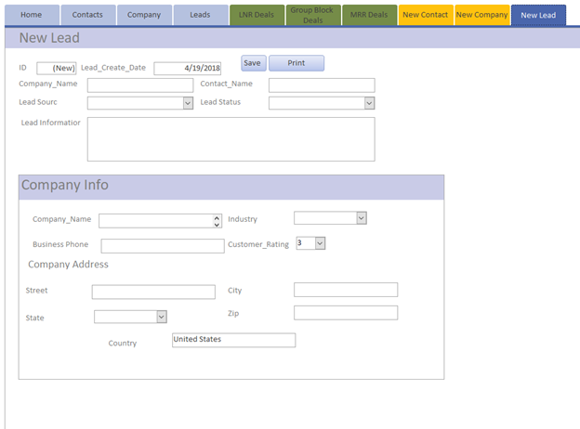

Then enter the Company and Contact name that you already and the Company Data will automatically populate the Company Information section of the form. Finish filling out Lead Source, Lead Status and Lead Information sections.

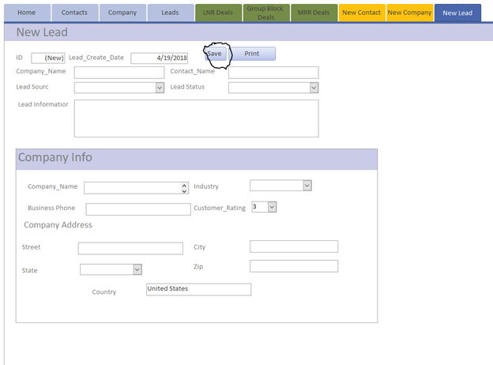

Save The form and navigate move on to doing something else in the software. You can also print the form from the new lead form. However, it is recommended to do this from the View leads form as it will contain more information about the lead.

**5 Contact**

**5.A Contact List**



Click the Contact button to navigate to the contact list. This lists all of the contacts that are in the system.

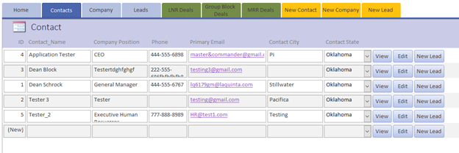

The Contact list gives you limited information about the contacts in the database. If you want to see more information about a specific contact simply click the view button on that contacts row. If you want to change the contacts data click the edit button. If you want to create a new lead using that contacts information click the new lead button.

**5.B View Contact**

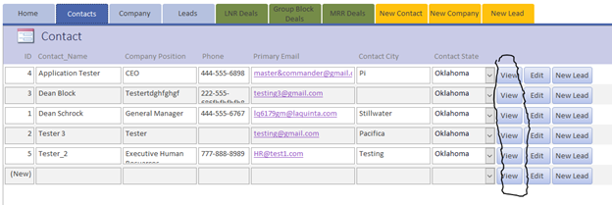

In order to view additional Contact information you will need to navigate to the contact list and then click the view button for the contact you are interested. This will let you see additional information about the contact.

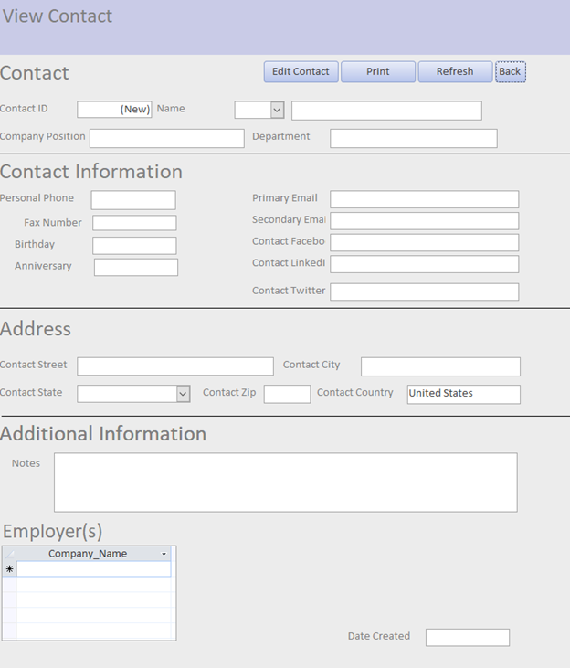

This lets you view all of the contact information for a specific contact.

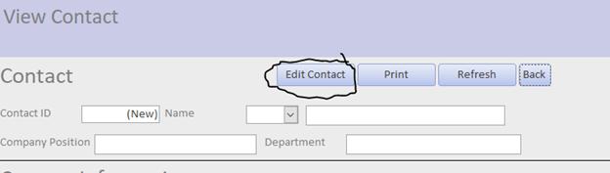

Click Edit Contact to edit the contacts information

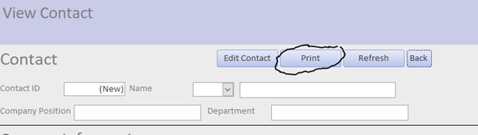

Click print to print the contact information

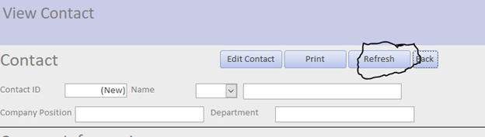

Click Refresh to ensure that the contact data is the current form of the data.

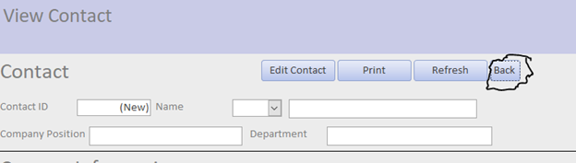

Click back to go back to the contact list

**5.C Edit Contact**

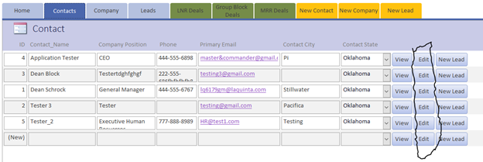

In order to Edit Contact information you will need to navigate to the contact list and then click the Edit button for the contact you are interested. This will let you Edit the contacts information.

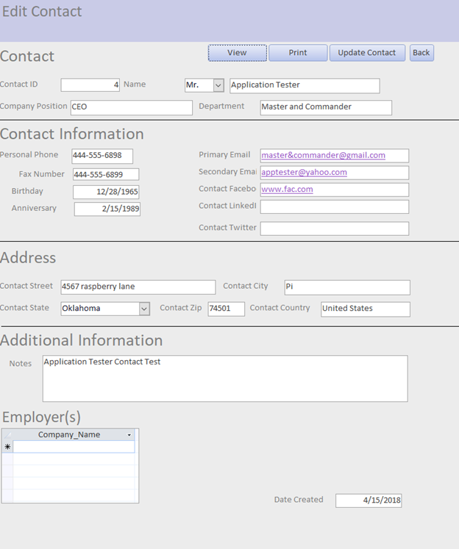

The Edit form allows you to change any of the contacts information.

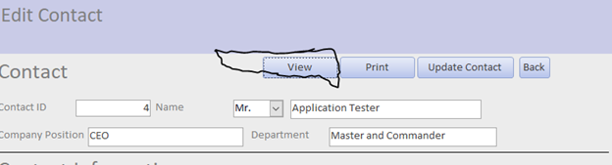

View button allows you to switch from Edit to view the form information.

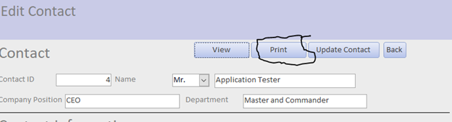

Print button allows you to print the updated contact information.

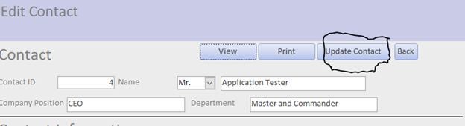

Update Contact button allows you to update the changed contact information. It is important to hit this button before navigating away from the Edit contact form.

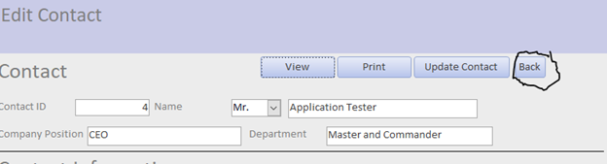

Back button takes you back to the Contact list.

**6 Company**

**6.A Company List**



The navigate to the company list click on the company button at the top of the navigation screen.

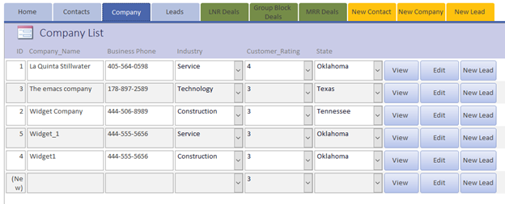

The Company list form lists all of the companies in the CRM software and allows you to View and Edit company data and also create New lead using the company data.

**6.B View Company**

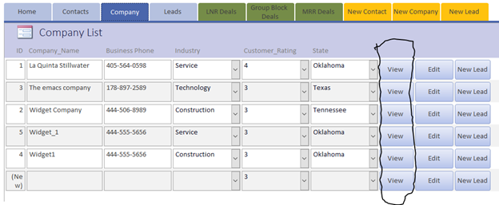

In order to view additional information about a specific company simply click the view button that corresponds to the company’s row.

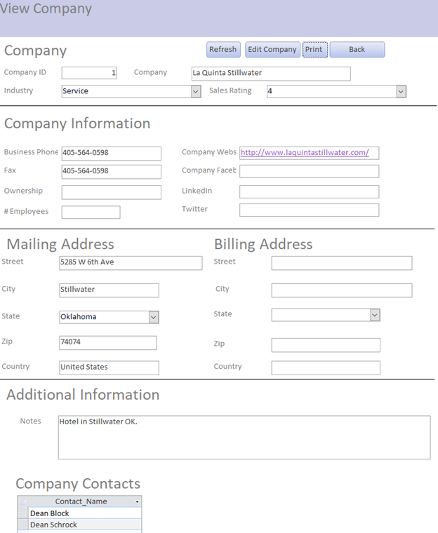

This navigates you to the view company form which shows all of the company data for the selected company.

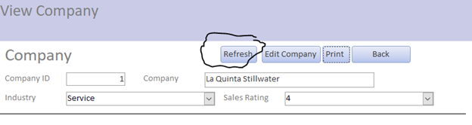

Refresh button allows you to makes sure you have the most up to date information about a company.

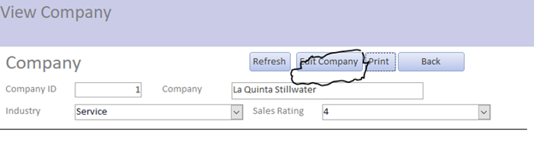

Edit button allows you to edit the company information.

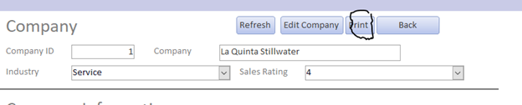

Print button allows you to print the company’s information.

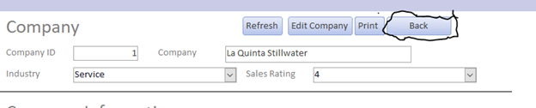

The back button allows to navigate back to the company list.

**6.C Edit Company**

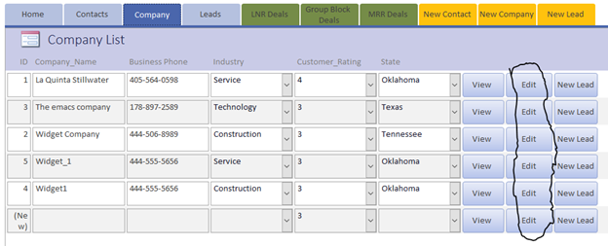

To Edit information about a specific company simply click the Edit button that corresponds to the company’s row.

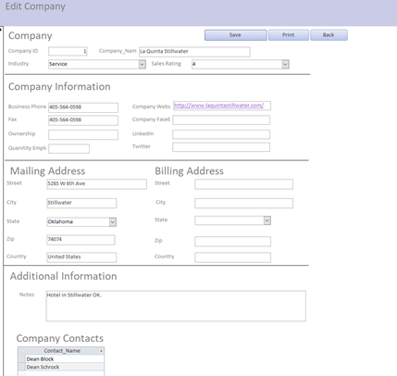

You now are at a screen that allows you to edit any of the company information.

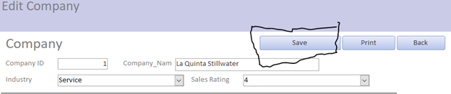

Save button allows you to save changes made to company’s information.

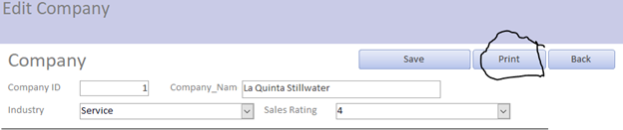

Print button lets you print updated company information.

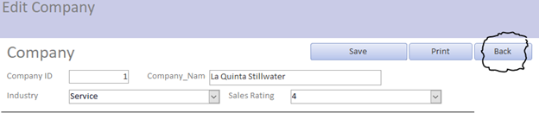

Back button navigates back to the company list form.

**7.0 Leads**

**7.A Leads list**



To navigate to the leads list click the leads button.

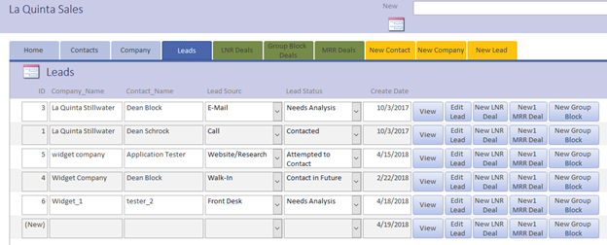

The Leads lists shows all of the leads that are currently in the CRM system. You have the ability to view additional information about lead or edit a lead. Additionally since lead is the transition between the contact management and deal management sides of the software you are also able to create LNR, MRR and Group Block from a lead.

**7.B View Lead**

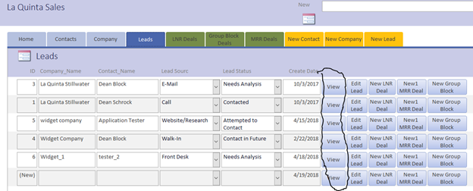

View lead information for a specific lead click the view button that corresponds to the lead row.

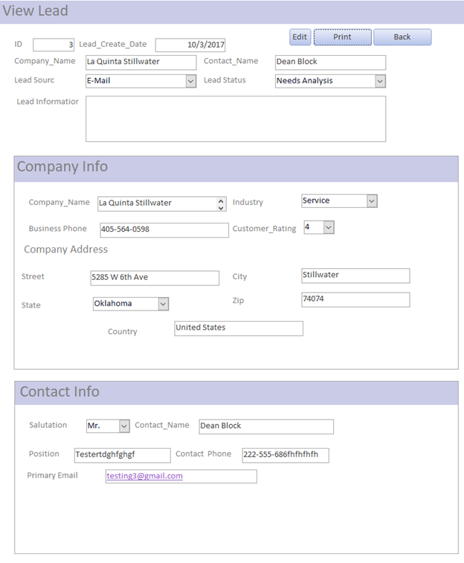

This allows you to view additional information about the lead

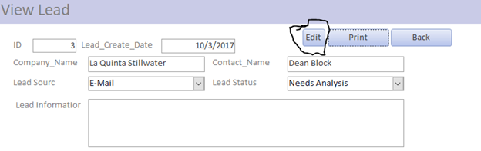

Edit button allows you to edit the lead information.

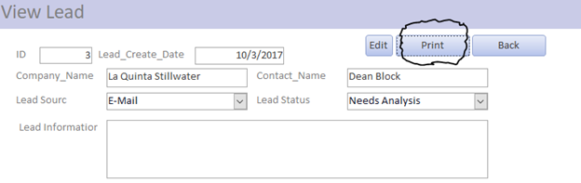

Print button allows you to print the lead information.

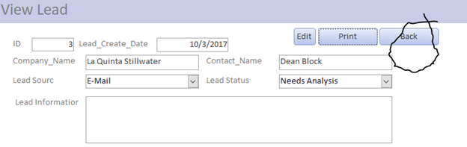

Back button navigates you back to the leads list form.

**7.C Edit Lead**

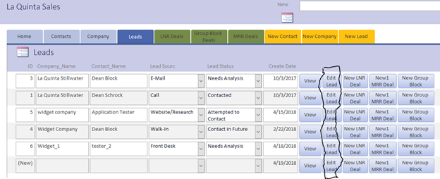

Edit lead information for a specific lead click the Edit button that corresponds to row you are interested in.

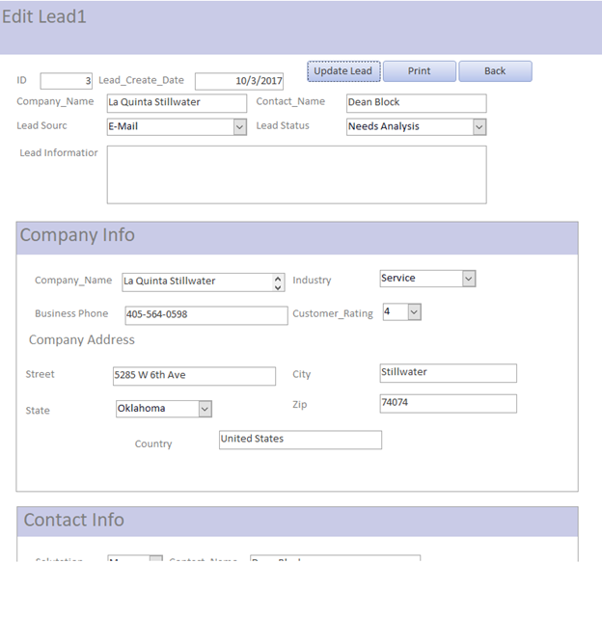

This allows you to edit the lead information. You cannot edit the company or contact information from this screen. To do that you need to update the information in the edit company or contact form.

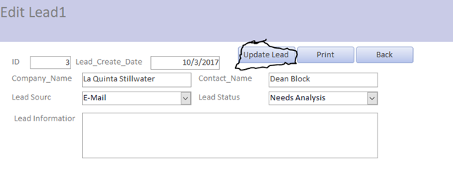

Update lead button saves the changes you made to the lead. It is important to save your changes before you navigate away from the form.

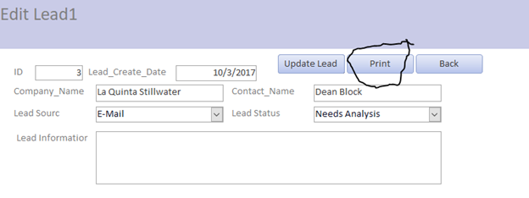

Print button allows you to print the update lead information.

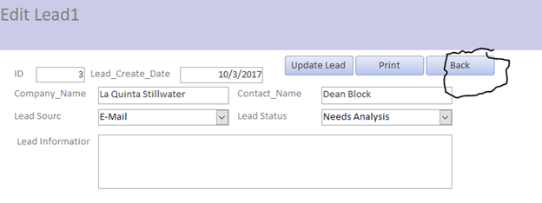

Back button navigates back to the lead list form.

**8.0 Local Negotiated Rate (LNR) Deals**

**8.A LNR Deal List**



To navigate to the LNR deal list click on the LNR Deals button on the top navigation menu.

**8.B Create New LNR Deal**



Navigate to leads list by clicking the leads button.

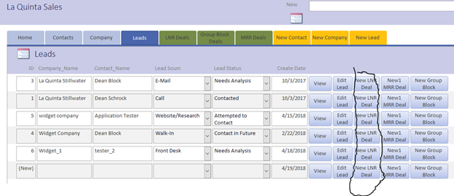

Click New LNR Deal button for the lead for which you want to create a new LNR Deal.

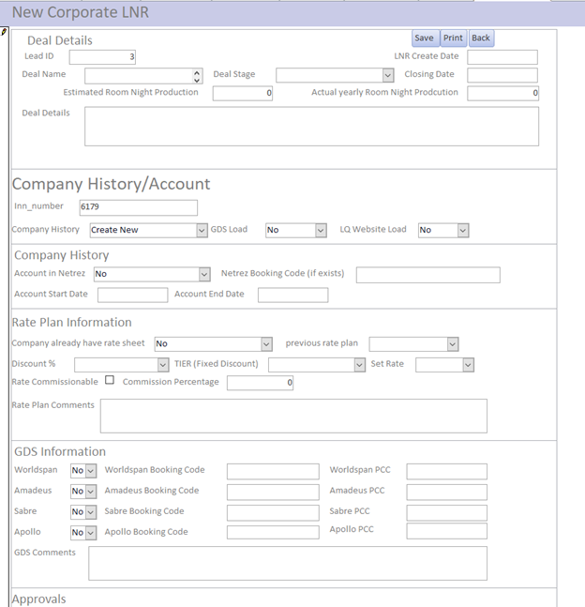

Fill out the information needed to complete the New LNR Deal.

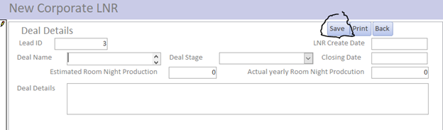

Click the save button to save the new LNR Deal

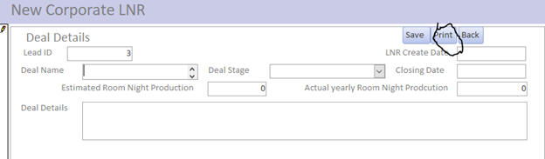

Click print button to print the new LNR Deal.

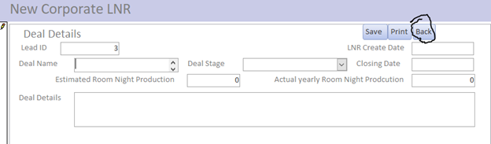

Click back button to navigate to the leads list.

**8.C View LNR Deal**

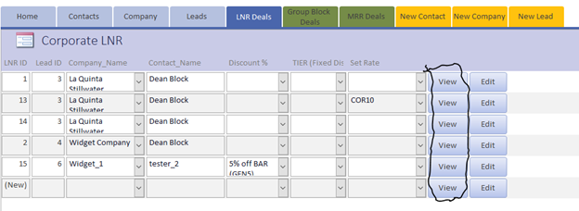

From the LNR Deals list click the view button for the LNR Deal that you want to view additional details about the Deal.

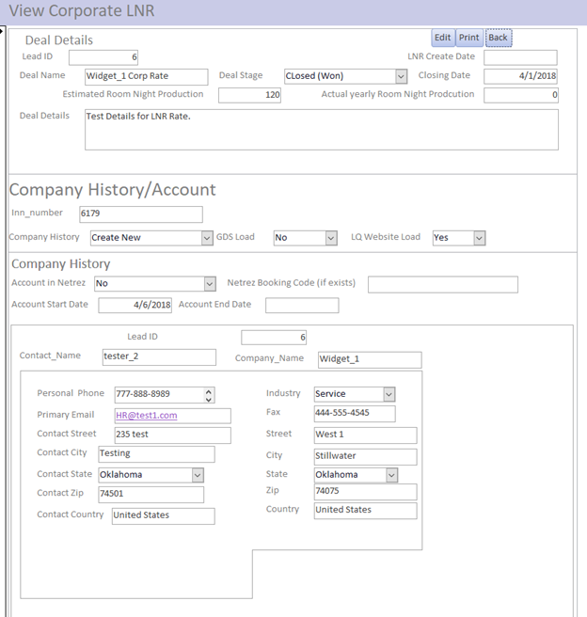

Now you can view details about corporate LNR Rate.

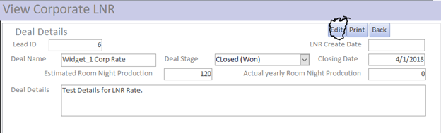

Click edit button to change details about the corporate LNR Rate.

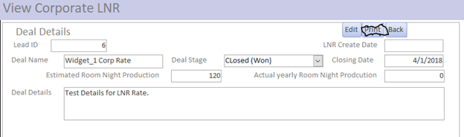

Click print button to print LNR deal information.

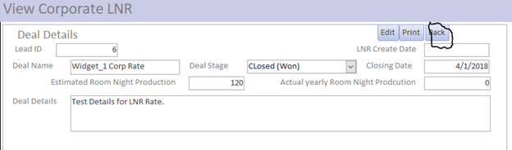

Click the back button to navigate back to the LNR Deals list.

**8.D Edit LNR Deal**

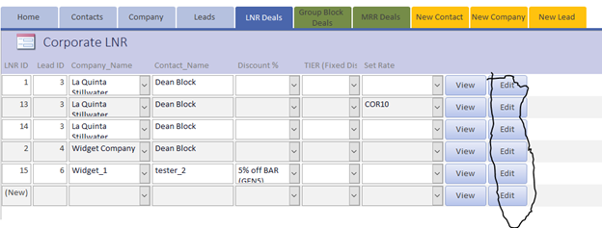

From the LNR Deals list click the Edit button for the LNR Deal that you want to Edit details about the Deal.

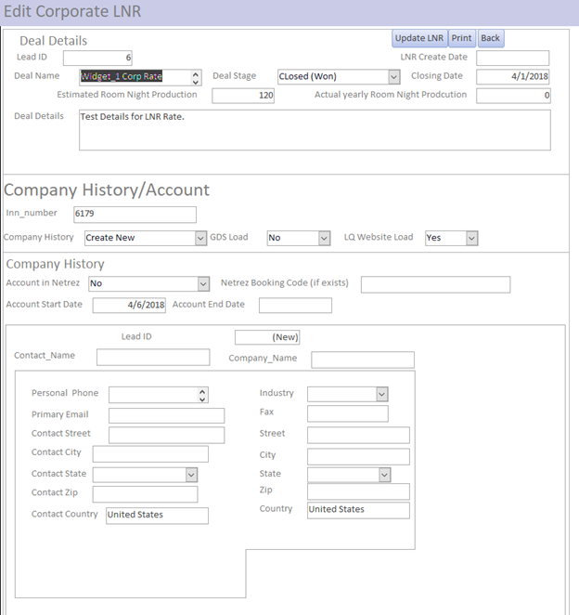

You can now edit any information about the LNR Deal. However you cannot edit lead, company or contact information. In order to edit that information go to the respective editing forms.

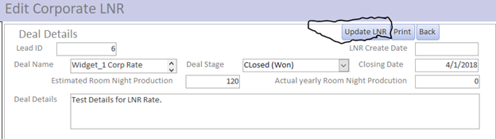

The update LNR button save the changes made to the LNR Deal, make sure to push this button if you make any changes before you navigate away from this page to ensure that the data is saved.

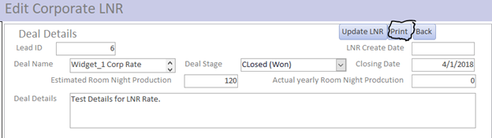

The print button prints the updated LNR Deal information.

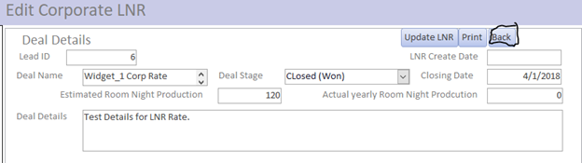

Back button navigates back to the LNR Deals list.

**9.0 Group Block Deals**

**9.A Group Block Deals List**



To navigate to the Group block Deals list click the Group Block Deals button on the top navigation menu.

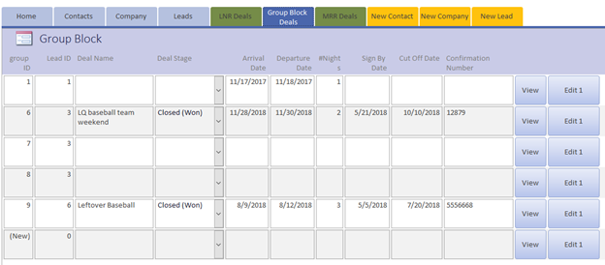

The Group Block Deals list shows all of the Group Block Deals that are saved in the system.

**9.B Create New Group Block Deal**



Click the leads button to navigate to the leads list.

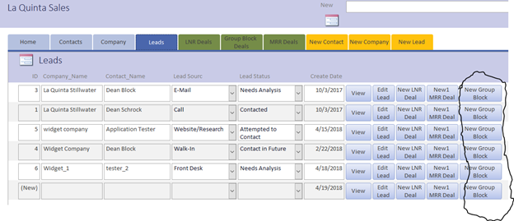

Click the new group block button for the lead you wish to convert into a new group block.

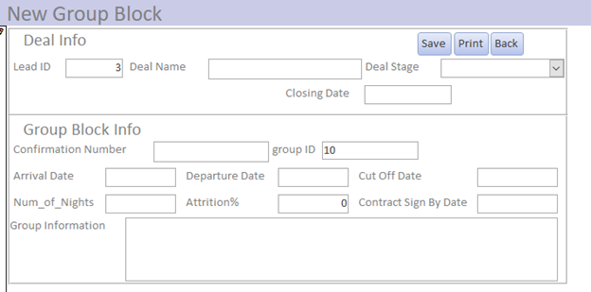

Input the relevant group block information. Always input a deal name so you can easily recognize the deal in the future.

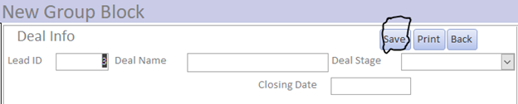

Click save to save the new group block.

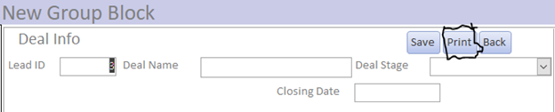

Click print to print the new Group Block Deal Information.

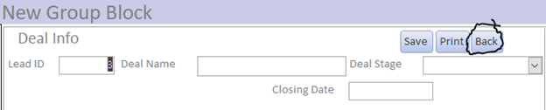

Click the back button to navigate to the Leads list form.

**9.C View Group Block**

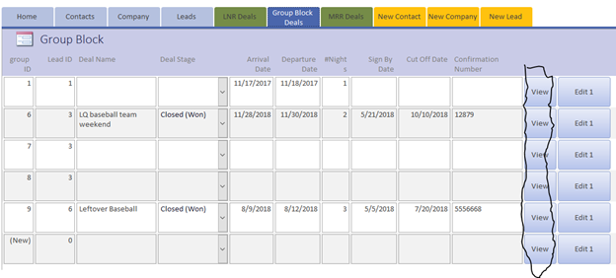

Click the view button for the group block you wish to view.

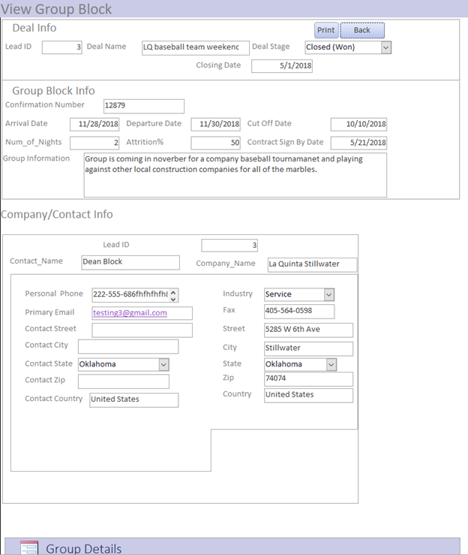

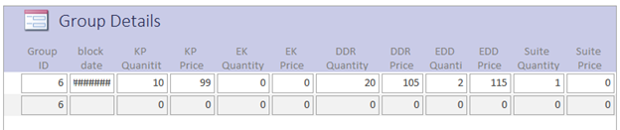Now you can view all of the details for the Group Block Deal.

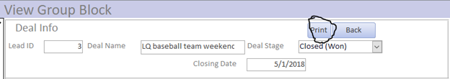

Click the print button to print the Group Block deal data.

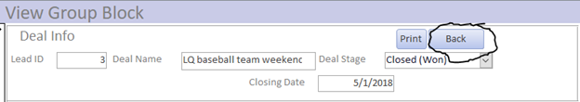

Click the back button to navigate back to the Group Block List form.

**9.D Edit Group Block**

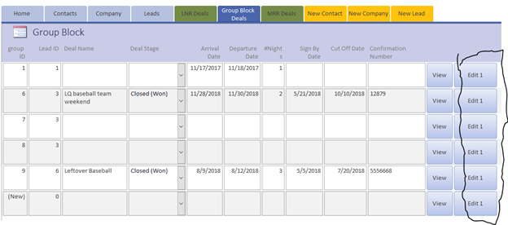

Click the Edit button for the group block you wish to Edit.

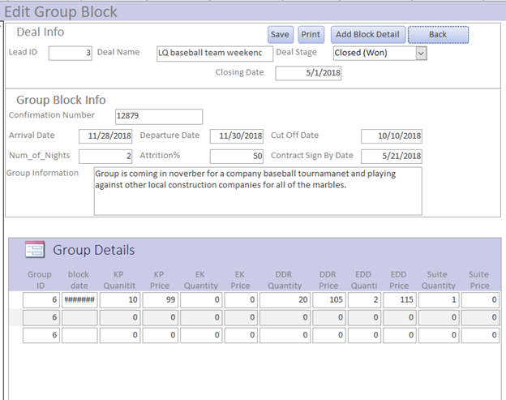

Now you can edit whatever Group block information you need.

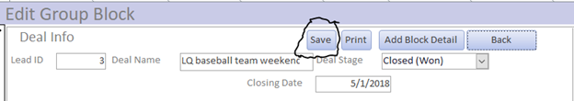

Click save to save any changes made to the Group block deal.

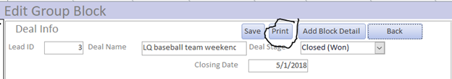

Click print to print the updated Group Block Deal.

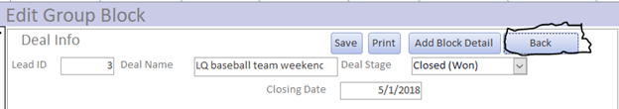

Click back to navigate to the Group block Deal List.

9.E Add Group Block Details

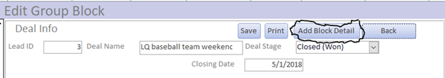

From the Edit group block form click the Add Block Detail Button.

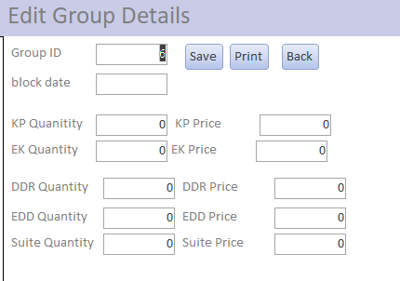

Then you can input all of the room information for a single night. This means that for Group blocks that span multiple nights you will have to repeat the Add group block detail for each night the group will be at the hotel.

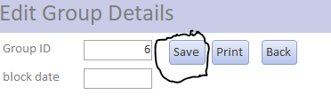

Save button saves the new Group details

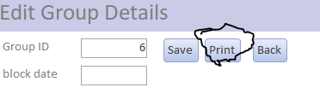

Print button prints the new group detail.

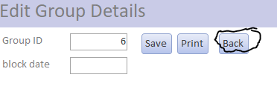

Back button navigates you to the previous Edit Form.

**10.0 Meeting Room Rental (MRR) Deals**

**10.A MRR Deals List**



To navigate to the MRR Deals list click the MRR Deals button.

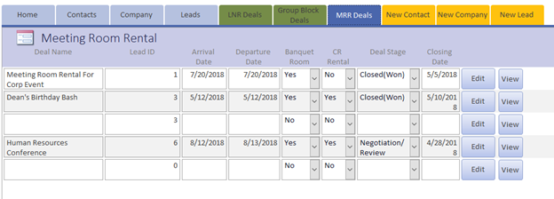

The MRR Deals list shows all of the Meeting Room Rental (MRR) Deals that are currently in the system.

**10.B Create New MRR Deal**



Navigate to the Leads list by clicking on the leads button.

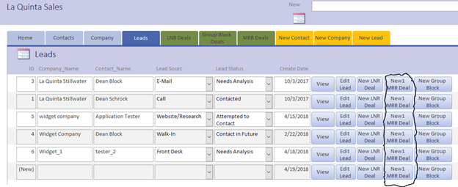

Click the New1 MRR Deal button for the lead you wish to convert to a new MRR Deal.

**10.C View MRR Deal**

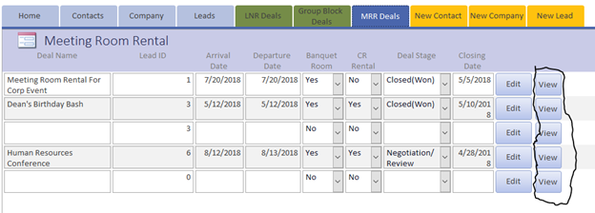

Click the View button for the MRR Deal you wish to View the deal details.

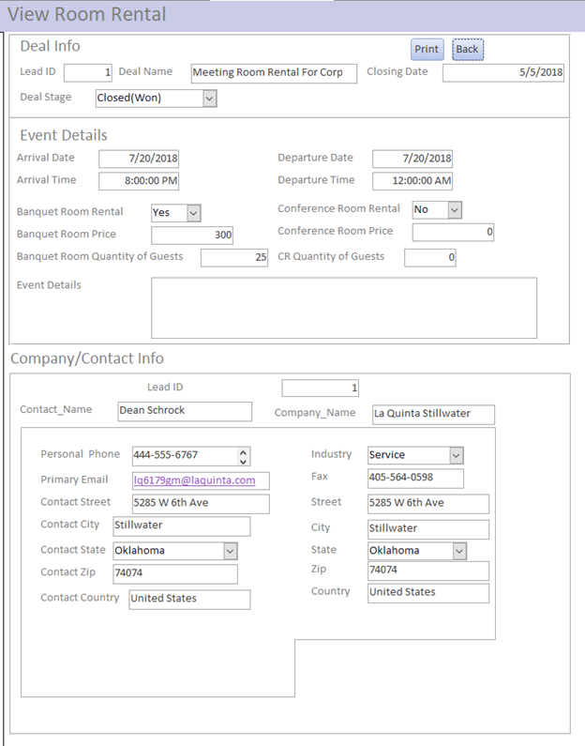

Now you can view all of the MRR deal information.

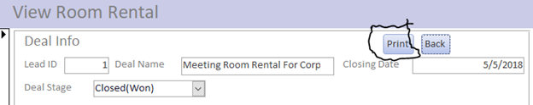

Click the print button to print the MRR Deal information.

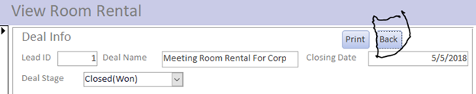

Click the back button to navigate to the MRR deals list.

**10.D Edit MRR Deal**

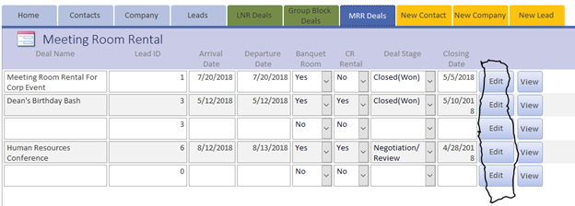

Click the Edit button for the MRR Deal you wish to Edit.

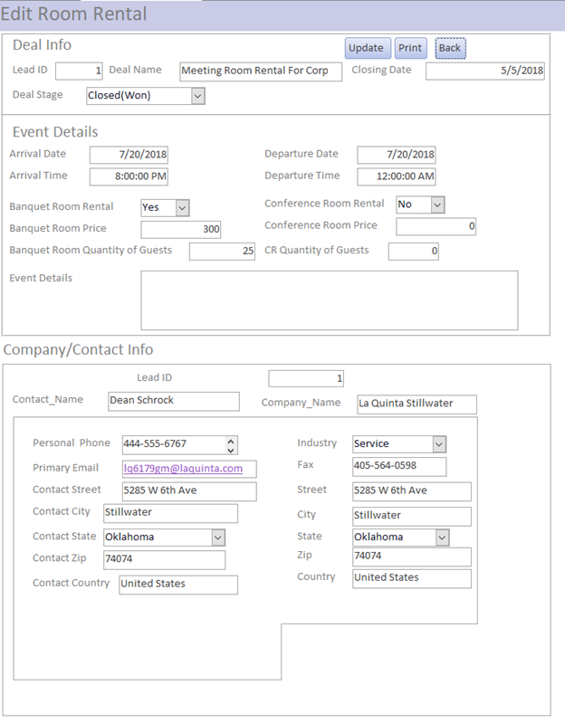

Now you can edit any MRR Deal information needed.

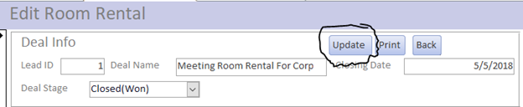

Click the Update button to save the changes to the MRR deal. Make sure to always click the save button after making any changes and before you navigate to another screen to ensure that the new updated information is not lost.

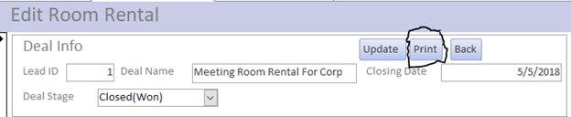

Click the print button to print the updated MRR Deal information.

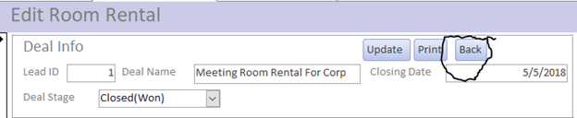

Click the back button to navigate to the MRR Deals list form.

**A.3**

**Test cases, Test Data and Test Results**

Due to small size of Apoco The test case, Test data and test results are curated into a single document that lists the case being tested. The action of the case being tested. The attribute and the value of the attribute being tested. Whether an action passed or failed and the details of any failures. The testing only resulted in two failures that did not correct themselves. These two failures were for case 1.2 were the view contact form continually failed to pull the data from the contact list. Current speculation is that there is a problem with the form setting that does not allow the macro to run properly that pulls the data from the contact list table.

The second failure was case 4.2, update LNR Deal. The problem was that the form lacked the required attributes to update the attributes outlined in case 4.2. This failure is easily remedied by updating the forms contents with the missing attributes from the LNR database table.

Other minor failures happened throughout testing were the first time a form was opened it would not populate the data from the previous form. This problem was remedied by simply navigating to the previous form and re-clicking on the same navigation button which would result in the correct data population from the previous form. This problem is probably due to the open form macro happening at the wrong time. It is currently running before the form loads and it may need to run at a different time.

